**IOT Smart Home Design in Packet Tracer**

Introduction

The aim of this task was to design and build an Internet of Things network based in Cisco Packet Tracer. This network would comprise of a minimum of and ISP called SHU-LTD a modem to the ISP and connected to the modem a home router system, this setup would then be connected to a range of IoT devices including but not limited to lamps, power meters solar panels and smoke detectors. All of the IoT devices would be connected to and registered on a central server that would be accessible and controlled by a tablet connected to the network wirelessly.

Methodology

This design was initially built from the ISP to the home router with the tablet and a simple power meter connected to the router was a cisco 2960 switch and connected to the switch a light with a motion detector. This system was built into the setup for initial connecting to the IoT service.

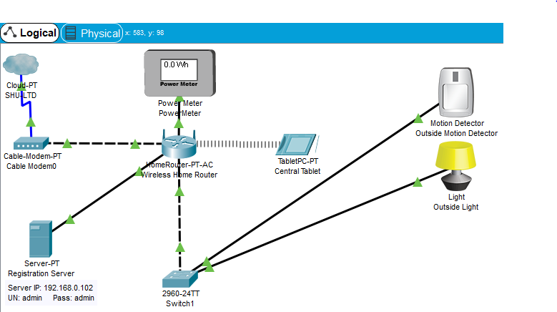

Fig.1 shows the initial placement of the ISP, Modem Home router, Tablet, server, switch, light motion sensor and Power meter.

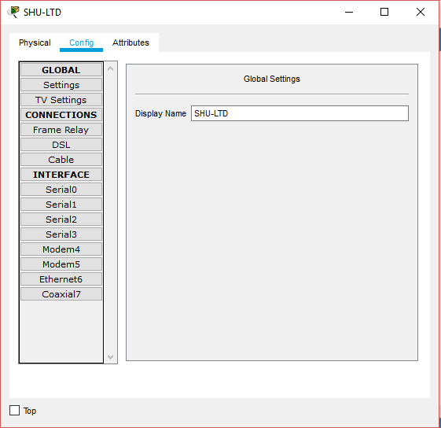

Fig.2 shows the global settings tab for the Cloud-PT.

The first thing to be placed down in this initial setup was the Cloud-PT WAN emulator acting as an ISP which was renamed to SHU-LTD (Fig.2).

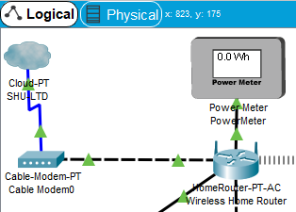

Fig.3 showing the Cloud-PT (ISP) connected to the modem then the modem connected to the home router.

The SHU-LTD ISP was then connected to the modem. The modem configuration was left untouched. After the modem was connected to the home router the home router’s configuration was also left untouched for now (Fig.3).

Connected to the home router system was a power meter a server tower and a cisco 2960 switch this switch was designed to maximise the amount of ethernet ports available in the system. Connected to the home router via a wireless connection was the control tablet (Fig.1). The first thing that was setup was the server tower to act as a registration server for the IoT devices on the network and also to provide some of the basic rules for the server (Fig.4, 5, 6)

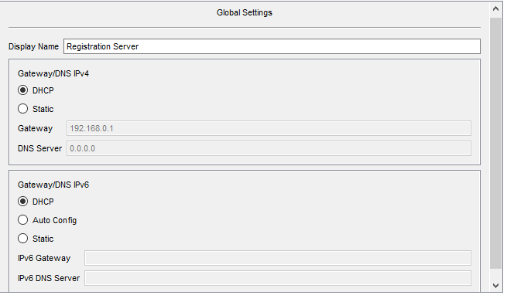

Fig.4 showing the initial setup of the server tower’s global settings. The display name was changed to Registration server and the IPv4 and IPv6 gateway/DNS settings were set to DHCP.

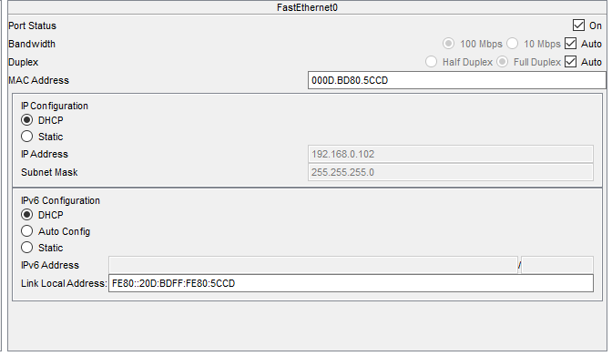

Fig.5 showing the setup of the Fast ethernet port of the server tower both ipv4 and IPv6 are set to DHCP setting to get what they need from the home router.

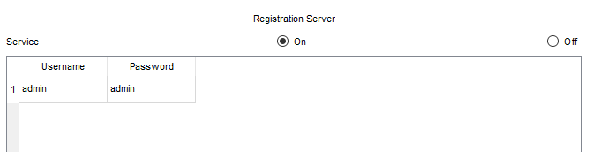

Fig.6 showing the setup for the IoT services page with the Registration server set to on and a basic login system implemented to get the system off the ground.

With the initial setup of the server complete the next thing to do was to connect the power meter, the light and the motion sensor all of the fast ethernet ports for these devices were connected to the switch other than the power meter with the DHCP setup selected for both IPv4 and 6. The motion sensor and the light work on the idea of an outside light such that when the motion sensor is tripped the light will come on and when the sensor is no longer being tripped the light would go off again. These rules were quickly implemented and tested (Fig.7, 8, 9, 10, 11).

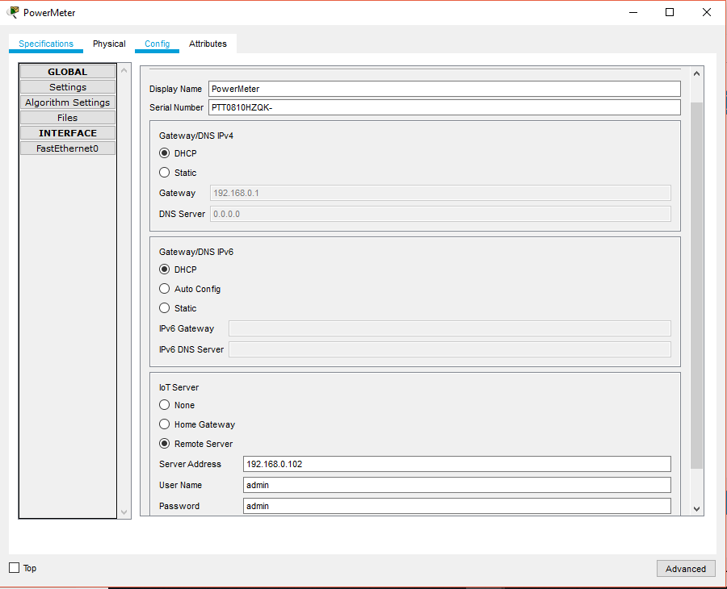

Fig.7 showing the global settings for the power meter showing its IPv4/6 gateway and DNS settings and the IoT server settings.

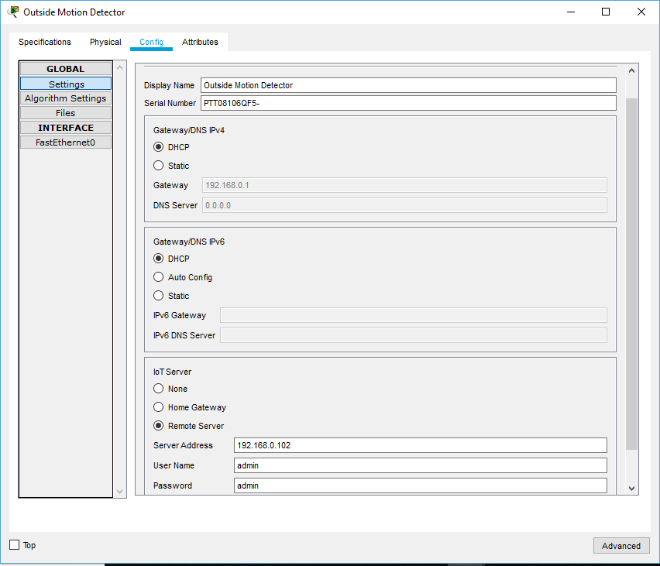

Fig.8 showing the global settings for the outside motion detector detailing its IPv4/6 gateway and DNS settings and the IoT server settings.

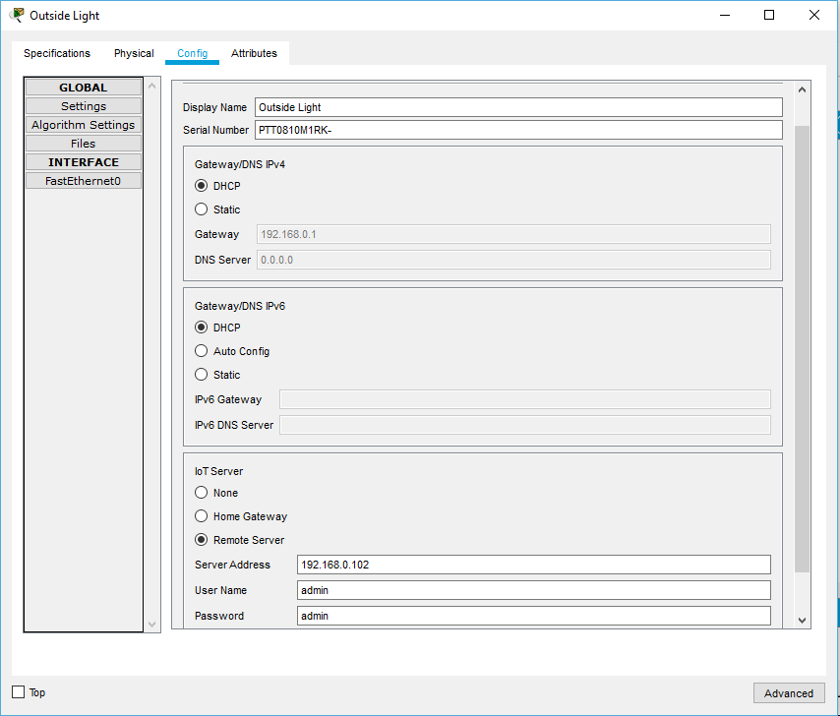

Fig.9 showing the global settings for the outside light detailing its IPv4/6 gateway and DNS settings and the IoT server settings.

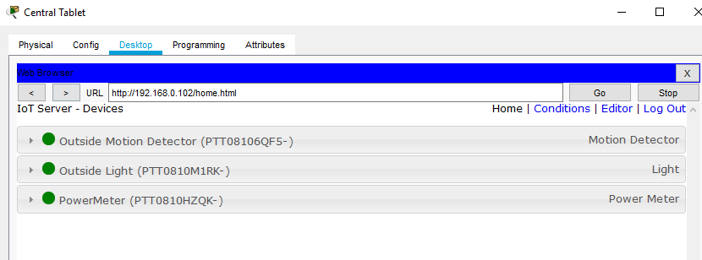

Fig.10 a screenshot from the central tablet’s web browser after logging into the Registration server’s webservice this page shows all of the connected devices.

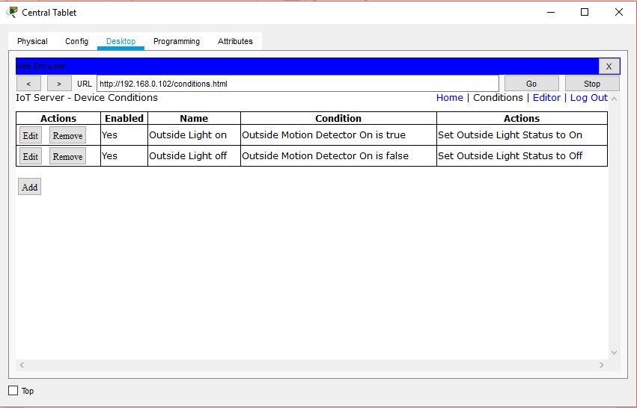

Fig.11 showing the rules for the outside motion detector and the outside light.

Having initially placed the basics for the home IoT solution the setup for the rest of the IoT devices could begin to be placed. This started with the addition of an IoT door that could be locked, unlocked and monitored from the tablet.